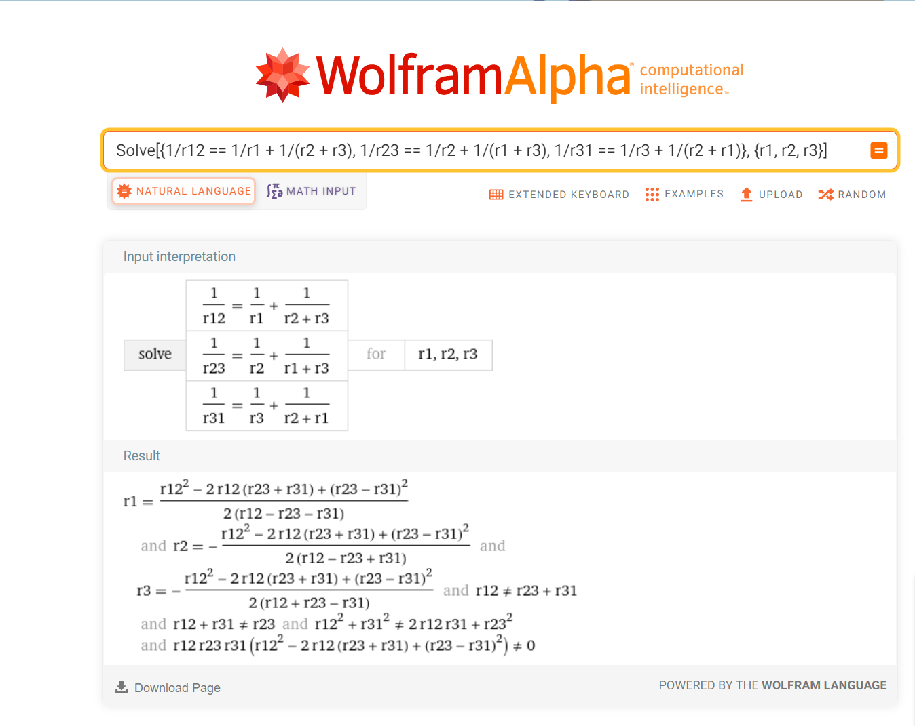

Solve[{1/r12 == 1/r1 + 1/(r2 + r3), 1/r23 == 1/r2 + 1/(r1 + r3), 1/r31 == 1/r3 + 1/(r2 + r1)}, {r1, r2, r3}]

https://www.wolframalpha.com/input?i=Solve%5B%7B1%2Fr12+%3D%3D+1%2Fr1+%2B+1%2F%28r2+%2B+r3%29%2C+1%2Fr23+%3D%3D+1%2Fr2+%2B+1%2F%28r1+%2B+r3%29%2C++++1%2Fr31+%3D%3D+1%2Fr3+%2B+1%2F%28r2+%2B+r1%29%7D%2C+%7Br1%2C+r2%2C+r3%7D%5D

